**Shandong University of Technology**

**Digital Image Processing quiz 01**

|  |  |
| --- | --- |
| ID No | Name Of Student |
| 27 | Mohanto Tushar Chandra |

1. For every year, the average temperature and rainfall of each month in city ‘A’ are shown in the table below.
2. Please draw curves for the changes of the rainfall and temperature along the changing of the months. Please label the titles of the coordinate axes, the location of the given points and the corresponding values.
3. Display the two curves in one figure window.

(There are examples below Table1.)

Table1 Temperature-rainfall values

|  |  |  |
| --- | --- | --- |
| month | Temperature(℃) | Rainfall(mm) |
| 1 | 0.2 | 4.6 |
| 2 | 2.3 | 3.6 |
| 3 | 8.7 | 2.1 |
| 4 | 18.5 | 2.9 |
| 5 | 24.6 | 3.0 |
| 6 | 32.1 | 2.7 |
| 7 | 36.8 | 2.2 |
| 8 | 37.1 | 2.5 |
| 9 | 28.3 | 4.3 |
| 10 | 17.8 | 3.4 |
| 11 | 6.4 | 2.1 |
| 12 | -3.2 | 3.7 |

Example:

**the location and the corresponding values**

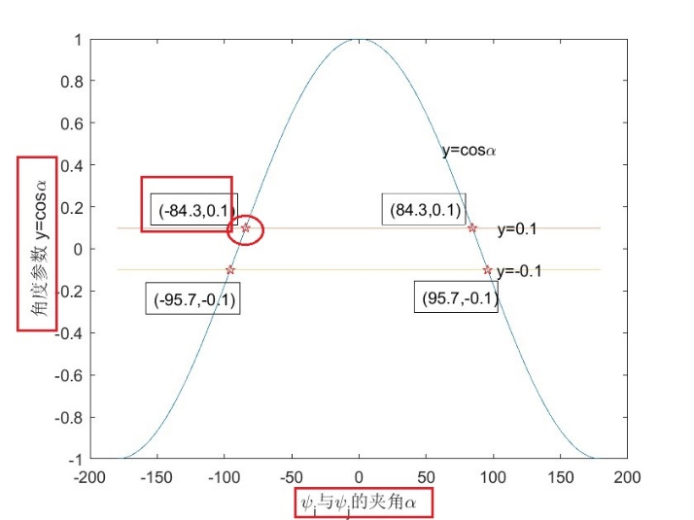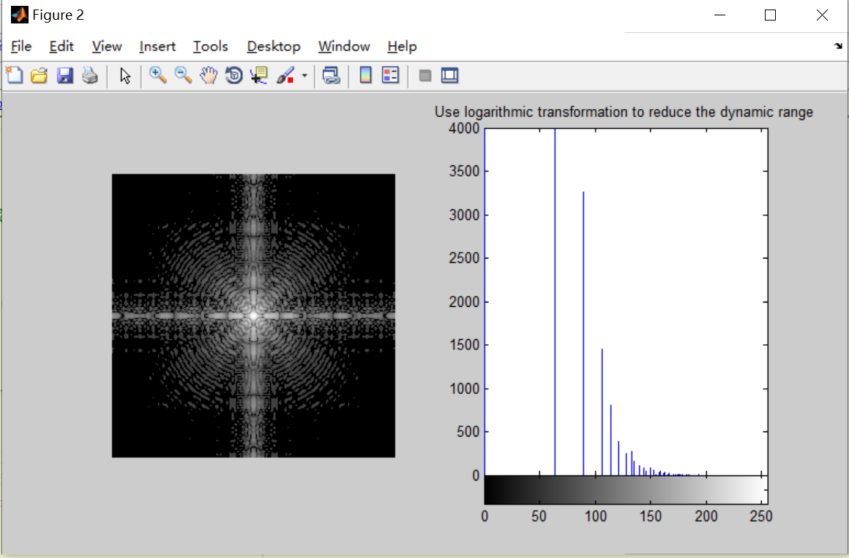

**SOLUTION:**

**The titles of the axes,**

x = [1, 2, 3, 4, 5, 6, 7, 8, 9, 10, 11, 12]

y1 = [0.2, 2.3, 8.7, 18.5, 24.6, 32.1, 36.8, 37.1, 28.3, 17.8, 6.4, -3.2]

y2 = [4.6, 3.6, 2.1, 2.9, 3.0, 2.7, 2.2, 2.5, 4.3, 3.4, 2.1, 3.7]

subplot(121),plot(x,y1),subplot(122),plot(x,y2)

hold on;

subplot(121), title('temperature & months')

subplot(121),xlabel('months'),ylabel('temperature')

subplot(122), title('months & rainfall')

subplot(122),xlabel('months'),ylabel('rainfall')

